1.LED

#define LED_PIN 8
#define BUTTON_PIN 7
void setup() {
pinMode(LED_PIN, OUTPUT);
pinMode(BUTTON_PIN, INPUT);
}
void loop() {
if (digitalRead(BUTTON_PIN) == HIGH) {
digitalWrite(LED_PIN, HIGH);
}
else {
digitalWrite(LED_PIN, LOW);
}
}

Toggling
#define LED_PIN 8
#define PUSH_BUTTON 7

int ledState = LOW;
int lastButtonState = LOW;

void setup() {
pinMode(LED_PIN, OUTPUT);
pinMode(PUSH_BUTTON, INPUT);

}

void loop(){

int currentButtonState = digitalRead(PUSH_BUTTON);
if (currentButtonState == HIGH && lastButtonState == LOW) {
ledState = !ledState;
digitalWrite(LED_PIN, ledState);
delay(50);
}
lastButtonState = currentButtonState;
}

2.Temp sensor
float temp;
int tempPin = 0;
void setup(){
Serial.begin(9600);
}

void loop(){
temp = analogRead(tempPin);
Serial.print("TEMPREATURE =");
Serial.print(temp);
Serial.print("*C");
Serial.println();
delay(1000);
}

3.Ultrasonic sensor
const int pingPin = 7;
const int echoPin = 6;

void setup(){
Serial.begin(9600);
pinMode(pingPin, OUTPUT);
pinMode(echoPin, INPUT);
}

void loop (){
long duration , inches, cm;
digitalWrite(pingPin, LOW);
delayMicroseconds(2);
digitalWrite(pingPin, HIGH);
delayMicroseconds(10);
digitalWrite(pingPin, LOW);

duration = pulseIn(echoPin, HIGH);

inches = microsecondsToInches(duration);
cm = microsecondsToCentimeters(duration);

Serial.print(inches);
Serial.print("in, ");
Serial.print(cm);
Serial.print("cm");
Serial.println();

delay(100);
}

long microsecondsToInches(long microseconds) {
return microseconds / 74 / 2;
}

long microsecondsToCentimeters(long microseconds) {
return microseconds / 29 / 2;
}

4. PIR sensor
int pirsensor = 0;
void setup(){
pinMode(2, INPUT);
pinMode(13, OUTPUT);
Serial.begin(9600);
}
void loop(){
pirsensor = digitalRead(2);
if (pirsensor == 1){
digitalWrite(13, HIGH);
Serial.println("motion detected, persence of object");
}
else {
digitalWrite(13, LOW);
Serial.println("motion not detected");
}
delay(1000);
}

6.DHT11 ESP 8266
#include <ESP8266WiFi.h>
#include "ThingSpeak.h"
#include "DHT.h"

#define DHTPIN D4
#define DHTTYPE DHT11

#define MQ3_PIN A0

const char* ssid = "Vipul";
const char* password = "00000000";

unsigned long channelID = 3327380;
const char* writeAPIKey = "9X7HMZENZX10OLOQ";

WiFiClient client;
DHT dht(DHTPIN, DHTTYPE);

void setup() {
Serial.begin(115200);
dht.begin();

WiFi.begin(ssid, password);
Serial.print("Connecting");

while (WiFi.status() != WL_CONNECTED) {
delay(500);
Serial.print(".");
}

Serial.println("\nConnected to WiFi");

ThingSpeak.begin(client);
}

void loop() {

float humidity = dht.readHumidity();
float temperature = dht.readTemperature();

int smokeValue = analogRead(MQ3_PIN);

Serial.print("Temperature: ");
Serial.println(temperature);

Serial.print("Humidity: ");
Serial.println(humidity);

Serial.print("Smoke Level: ");
Serial.println(smokeValue);

ThingSpeak.setField(1, temperature);
ThingSpeak.setField(2, humidity);
ThingSpeak.setField(3, smokeValue);

ThingSpeak.writeFields(channelID, writeAPIKey);

delay(15000); // ThingSpeak limit
}

6. Rain drop sensor
const int sensorMin = 0; const int sensorMax = 1024; void setup()
{
Serial.begin(9600);
}
void loop()
{
int sensorReading = analogRead(A0);
int range = map(sensorReading, sensorMin, sensorMax, 0, 3); switch (range)
{
case 0: Serial.println("RAINING"); break;
case 1:
Serial.println("RAIN WARNING"); break;
case 2:
Serial.println("NOT RAINING"); break;
}
delay(1000);

Soil Moisture Sensor:
Analog Mode
int sensor_pin = A0; int output_value ; void setup() { Serial.begin(9600);
Serial.println("Reading From the Sensor ..."); delay(2000);
}
void loop() {
output_value= analogRead(sensor_pin); output_value =
map(output_value,550,0,0,100); Serial.print("Mositure : ");
Serial.print(output_value);
Serial.println("%"); delay(1000);
}
Digital Mode
int led_pin =13;
int sensor_pin =8; void setup() {
pinMode(led_pin, OUTPUT); pinMode(sensor_pin, INPUT);
}
void loop()
{
if(digitalRead(sensor_pin) == HIGH)
{
digitalWrite(led_pin, HIGH); } else
{
digitalWrite(led_pin, LOW); delay(1000);
}}}

interface LDR Sensor
int sensorPin = A0;
// select the input pin for LDR int sensorValue = 0;
// variable to store the value coming from the sensor void setup()
{
Serial.begin(9600); //sets serial port for communication
}
void loop()
{
sensorValue = analogRead(sensorPin);
// read the value from the sensor Serial.println(sensorValue);
//prints the values coming from the sensor on the screen delay(100);
}

Motor Spin
int enablePin = 9;
int in1 = 8;
int in2 = 7;
int potPin = A0;
int buttonPin = 2;

int motorSpeed = 0;
bool direction = true;
bool lastButtonState = HIGH;

void setup() {
pinMode(enablePin, OUTPUT);
pinMode(in1, OUTPUT);
pinMode(in2, OUTPUT);
pinMode(buttonPin, INPUT_PULLUP);
}

void loop() {
// Read potentiometer
int potValue = analogRead(potPin);
motorSpeed = map(potValue, 0, 1023, 0, 255);

// Button press detection
bool buttonState = digitalRead(buttonPin);

if (buttonState == LOW && lastButtonState == HIGH) {
direction = !direction;
delay(200); // debounce
}
lastButtonState = buttonState;

// Direction control
if (direction) {
digitalWrite(in1, HIGH);
digitalWrite(in2, LOW);
} else {
digitalWrite(in1, LOW);
digitalWrite(in2, HIGH);
}

// Speed control
analogWrite(enablePin, motorSpeed);
}

LCD Interface

#include <LiquidCrystal.h>

// sets the interfacing pins (RS, E, D4, D5, D6, D7)
LiquidCrystal lcd(12, 11, 5, 4, 3, 2);

void setup() {
lcd.begin(16, 2); // initializes the 16x2 LCD
}

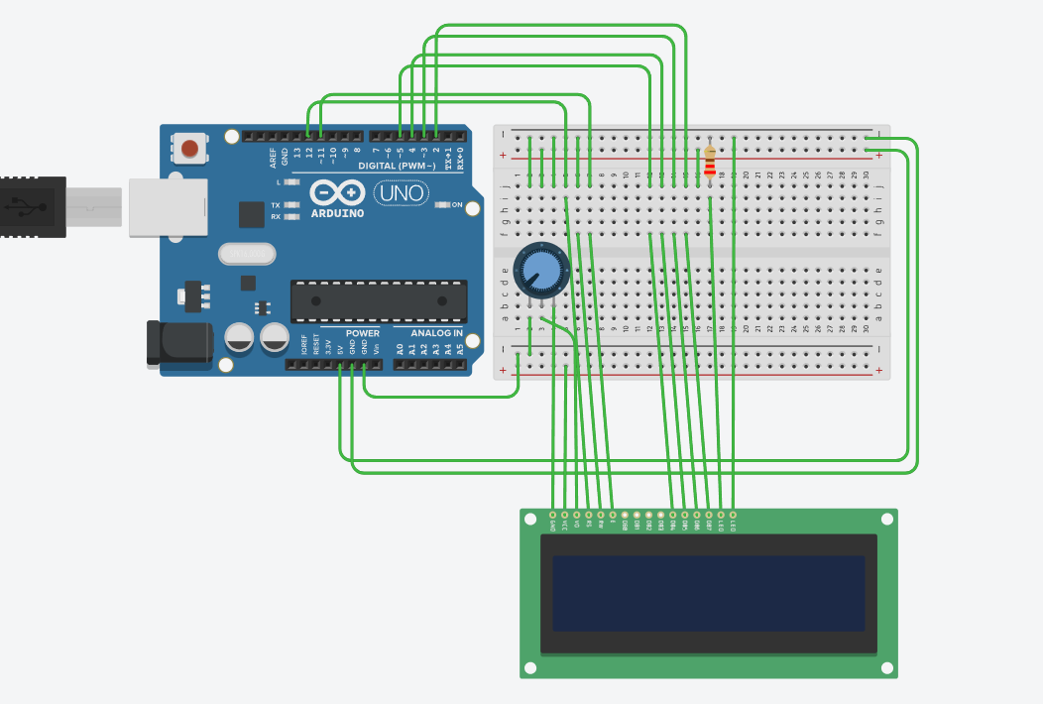
void loop() {
lcd.setCursor(0, 0);
lcd.print("16x2 LCD MODULE");
lcd.setCursor(2, 1);
lcd.print("hello, world!");
}

Relay control
#include <ESP8266WiFi.h>

const char* ssid = "Falcon";
const char* password = "falcon@2025";

int relayPin = 13; // D7 GPIO13
WiFiServer server(80);

void setup() {
Serial.begin(115200);
pinMode(relayPin, OUTPUT);
digitalWrite(relayPin, HIGH);

WiFi.begin(ssid, password);

while (WiFi.status() != WL_CONNECTED) {
delay(500);
Serial.print(".");
}

Serial.println("WiFi connected");
server.begin();
Serial.println(WiFi.localIP());
}

void loop() {
WiFiClient client = server.available();
if (!client) return;

while(!client.available()) delay(1);

String request = client.readStringUntil('\r');
client.flush();

if (request.indexOf("/LED=ON") != -1) {
digitalWrite(relayPin, LOW);
}

if (request.indexOf("/LED=OFF") != -1) {
digitalWrite(relayPin, HIGH);
}

client.println("HTTP/1.1 200 OK");
client.println("Content-Type: text/html");
client.println("");
client.println("<html>");
client.println("<h1>Bulb Control</h1>");
client.println("<a href=\"/LED=ON\"><button>Turn ON</button></a>");
client.println("<a href=\"/LED=OFF\"><button>Turn OFF</button></a>");
client.println("</html>");

delay(1); // Small delay to give the web browser time to receive the data
} // <--- Add this missing closing bracket!

Home automation

#include <Servo.h>

Servo door;

int pirPin = 2;
int trigPin = 10;
int echoPin = 11;
int motorEnable = 9;
int in1 = 8;
int in2 = 7;
int tempPin = A0;

int ledMotion = 3;
int ledTemp = 4;

void setup() {
pinMode(pirPin, INPUT);
pinMode(trigPin, OUTPUT);
pinMode(echoPin, INPUT);

pinMode(in1, OUTPUT);
pinMode(in2, OUTPUT);
pinMode(motorEnable, OUTPUT);

pinMode(ledMotion, OUTPUT);
pinMode(ledTemp, OUTPUT);

door.attach(6);
Serial.begin(9600);
}

void loop() {

//PIR Sensor
int motion = digitalRead(pirPin);
digitalWrite(ledMotion, motion);

// Ultrasonic
digitalWrite(trigPin, LOW);
delayMicroseconds(2);
digitalWrite(trigPin, HIGH);
delayMicroseconds(10);
digitalWrite(trigPin, LOW);

long duration = pulseIn(echoPin, HIGH);
int distance = duration * 0.034 / 2;

if (distance < 20) {
door.write(90); // open
} else {
door.write(0); // close
}

// Temperature (LM35)
int tempValue = analogRead(tempPin);
float voltage = tempValue * (5.0 / 1023.0);
float temperature = voltage * 100;

if (temperature > 30) {
digitalWrite(in1, HIGH);
digitalWrite(in2, LOW);
analogWrite(motorEnable, 200);
digitalWrite(ledTemp, HIGH);
} else {
digitalWrite(in1, LOW);
digitalWrite(in2, LOW);
digitalWrite(ledTemp, LOW);
}
Serial.print("Temp: ");
Serial.println(temperature);
delay(500);
}

